Gas Laws, Mnemonic Devices and other assorted fun with Chemistry!

When teaching about the different gas laws hidden within the combined gas law, have students remember:
- Charlie Brown was a T V show.
(Charles’ Law relates temperature and volume)
- Boys Play Videogames
(Boyle’s Law relates pressure and volume)
- Gay-Lussac used T P on his Maypole

Low cost ways to investigate Gas Laws
- Boyle’s Law
  - Adding pressure:
    - In the soda aisle of a grocery store, repressurizing devices can be obtained. Fit one onto a clean one-liter water bottle that’s about ¼ full of mini-marshmallows. Pass it around the class, allowing them to increase the pressure on the marshmallows and have them compare to a beaker of reference marshmallows.

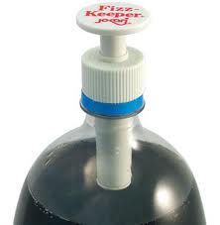
Fizz Keeper Fizz Keeper
Pump and Pour (both by Jokari)

  - Removing pressure:
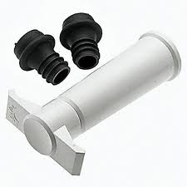
    - Carefully empty a clear wine bottle, wash out and remove labels.
    - Once the bottle is dry, fill about ¼ full with mini-marshmallows.
    - Fit Vacuvin plug onto the end. Affix pump and remove air, periodically stopping to shake marshmallows. Again, allow students to compare reference and resultant marshmallows.

- Charles’ Law
  - Dip small balloons into liquid nitrogen and let students watch as they magically flatten and then reinflate as the gas re-warms.
  - Marshmallow Peeps in the microwave make a wonderful visual aid to prove that as temperature increases, the volume will also increase.

Random mnemonic and other memory devices
- For acid name changes from anions, remember:

Mitey Mouse Ate something Icky and Dide an Hydro_ic death.

A colleague’s less bizarre ones:
Sprite is delicious.
I ate something icky.
My Ride has hydrol-ics.

- To recall the order of prefixes for alkanes, think of the sound the Road Runner made before running from the coyote:
“M-E-P-B”

- When trying to find functional groups, look for
The ether bunny’s nose or carbons on “ether” side

H₃C - CH₂ - O - CH₂ – CH₃

Aunt Ester’s glasses
O
||
H₃C-C- O - CH₂ – CH₃

Presented as a part of the IACT share-a-thon session @ HASTI conference, 2011
By Sarah Chattin (and Cathy Glick)
Hamilton Southeastern HS
13910 E. 126th St.
Fishers, IN 46033
317-594-4190
schattin@hse.k12.in.us

